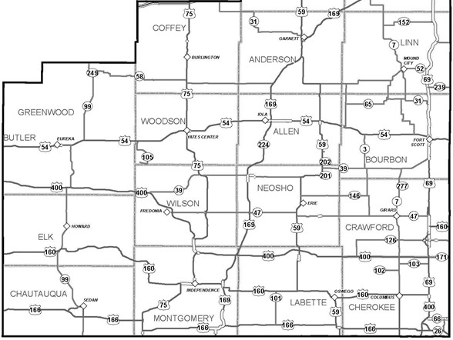

**West**

**East**

**Regions:** West Region: 3 Members East Region: 3 Members At Large: 1 Member

**Current Board** (Board offices are determined by the Board Members):

West Region Ray Rothgeb – Independence Historical Museum & Art Center - Independence *Leanne Githens – Wilson County Museum – Fredonia - President

Gina McBride – Caney – Communications Chair

East Region LeNoir Rowland – Mem-Erie Historical Society – Erie – East Region VP

*Jolene Born – Osage Mission – St. Paul – Treasurer

Carol Staton – Cherryvale Museum – Cherryvale – Secretary

At Large *Marcia Taylor-Trump – Howard Benson Museum – Howard – West Region VP

**SEK Museum Alliance Nomination Form  
* Denotes board position that is expiring**

**This nomination is for: (mark one)  
______ Regional position ___ At-Large position**

**Name of Nominee: Region:**

Name of Nominee’s Museum*

Nominator Name Region

Name of Nominator’s Museum*

*\*Museum must be in the SEK Region and a non-profit institution housed in a building in which objects of historical, scientific, artistic, or cultural interest are stored and exhibited.*

## SEK Museum Alliance Board Responsibilities

* Support the mission of the organization
* Meet four times a year and attend General Meetings
* Elect officers from among the current Board Members
* Manage the finances of the organization
* Determine and support activities and projects as determined by the board
* Determine organizational structure and by-laws as the organization matures
* Board communication is essential, and occurs through email and text messages in addition to the face-to-face meetings

## Board Nomination Process

1. Choose a nominee for the 2024 Board
   1. Nominee must give permission to have their name placed on the ballot
   2. Nominator must be from the same region as the Nominee
2. Current board members may be nominated
3. Provide a short bio of the nominee with qualifications for this type of position
4. One nominee per museum*
5. Email or mail the cut-off portion of this form:
   1. Email: [lgithens55@gmail.com](mailto:lgithens55@gmail.com)
   2. Mail: SEK Museums, P.O. Box 381, Independence, KS 67301
6. Nomination form must be received up to the time of the election
7. Elections will be held for positions with multiple candidates.
8. Nominee must be from a museum that has current paid membership.

*\*Museum must be in the SEK Region and a non-profit institution housed in a building in which objects of historical,*

*scientific, artistic, or cultural interest are stored and exhibited.*